***Smart water management***

# **1.Import the Dataset**:

* First, make sure you have access to the dataset containing relevant smart water management data. This data might include information about water usage, quality, temperature, and other relevant parameters.
* Depending on the source of your data, you may need to use different methods to import it. Common formats include CSV, Excel, or database connections.

**2. Data Cleaning**

Clean the dataset to ensure it’s suitable for analysis.

Handle missing data: Decide whether to impute missing values or remove rows/columns with missing data.

Check for duplicates and remove them if necessary.

Standardize or normalize data if needed.

**3. Data Analysis on IoT Platform:**

Choose an IoT platform that supports data analysis and visualization. Some popular options include AWS IoT, Google Cloud IoT, or Microsoft Azure IoT.

Set up your IoT platform and create a project/workspace.

Connect your dataset to the IoT platform, and establish a data pipeline to ingest data in real-time if applicable.

Perform data analysis tasks such as:

Descriptive statistics: Calculate mean, median, variance, etc., for relevant variables.

Time-series analysis: Examine trends and patterns in water usage data over time.

Correlation analysis: Identify relationships between different parameters.

Predictive modeling: Use machine learning algorithms to predict future water usage or detect anomalies.

Visualization: Create graphs, charts, and dashboards to visualize your findings.

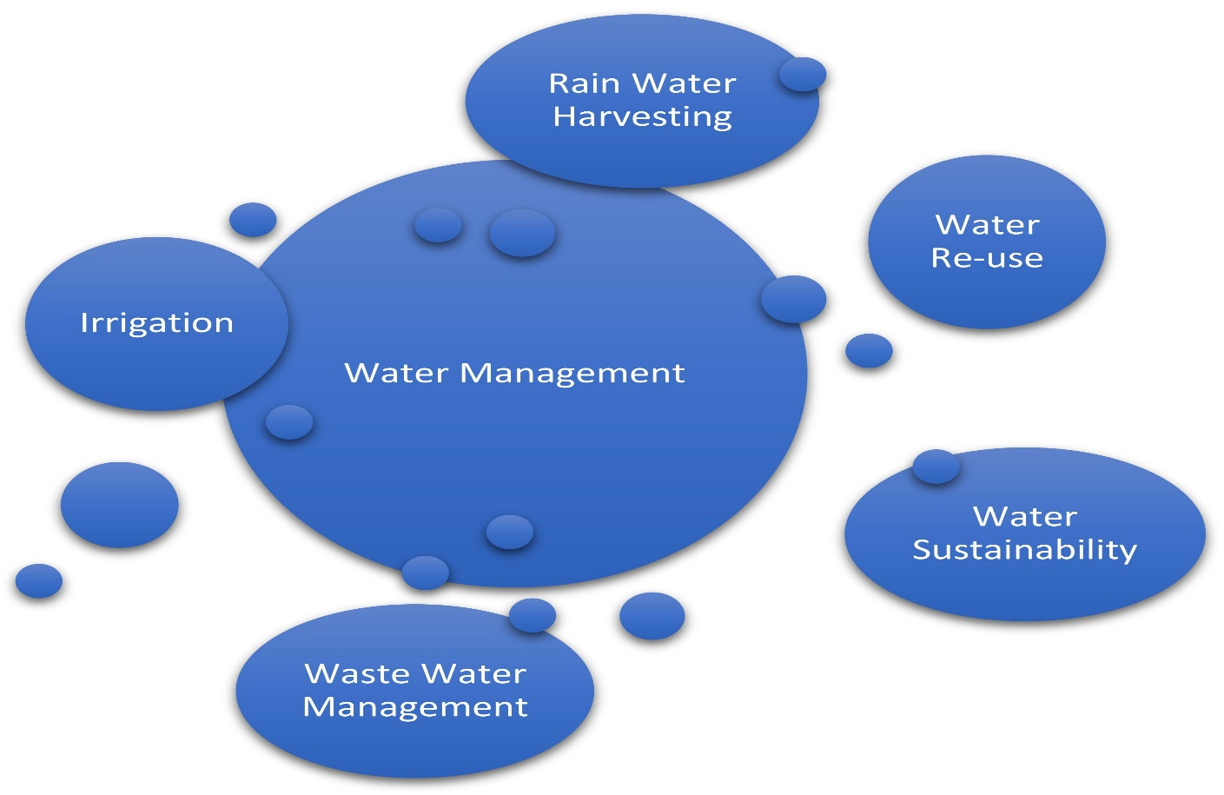

**4. Interpretation and Reporting:**

Interpret the results of your data analysis. What insights have you gained from the data?

Prepare a report or presentation summarizing your findings, including any actionable recommendations for smart water management.

Share your findings with relevant stakeholders or decision-makers.

**5. Continuous Monitoring and Improvement:**

* If this is an ongoing project, set up continuous monitoring of data and analysis to ensure that water management remains efficient.
* Continuously update your analysis as new data becomes available.
* Remember that the success of your smart water management project will depend on the quality of your data, the choice of IoT platform, and the rigor of your data analysis.

